# Compass MED D - Medicare D Landing Page

Medicare D Landing Page

Case Data

Medicare D Alerts

Medicare D Member Details

Medicare D Demographics

Center Panel

Medicare D Quick Actions

Related Documents

**Description:** This document outlines the Medicare D Landing Page and functionality found in Compass.

|  |
| --- |
| **Medicare D Landing Page** |

Each panel on the **Medicare D** Landing Page can house individual components that may require scroll bar use. When using the panel scroll bar, scrolling is dynamic. Refer to [Compass - Optimize the On-Screen Experience](../../../../../TSRC-PROD-049985) for more details.

The **Medicare D** Landing Page contains the following components:

1. Case Data
2. Medicare D Alerts
3. Medicare D Member Details
4. Medicare D Demographics
5. Center Panel

* Eligibility & Plan
* Premium Billing
* Member Resources

1. Medicare D Quick Actions

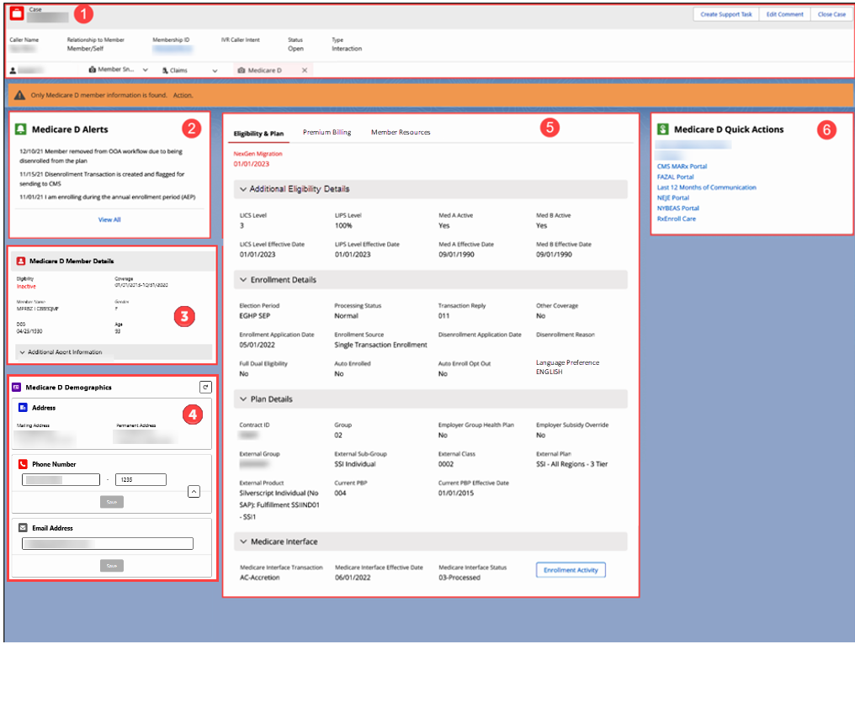

**Note:** When accessing the Medicare D Landing Page, if additional lines of eligibility exist for an MBI, the following Select Line of Eligibility screen displays:

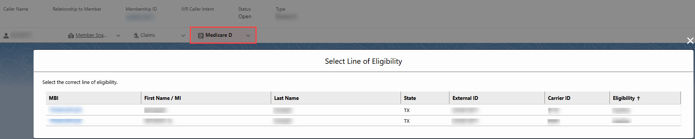

* Click the appropriate **MBI** hyperlink to open the member account.

**Result:** The Medicare D Landing page for the selected member account displays:

* Any transactions completed on the Medicare D Landing page are associated with the line of eligibility (**MBI** hyperlink) selected.

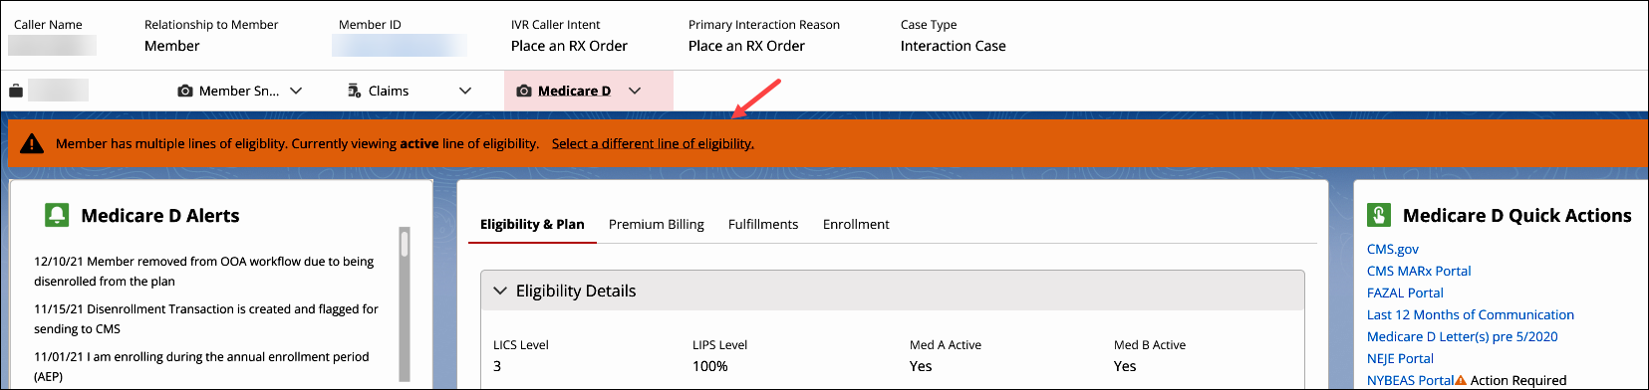

* **View Other Eligibility** hyperlink will also display in the **Medicare D Member Details** panel:

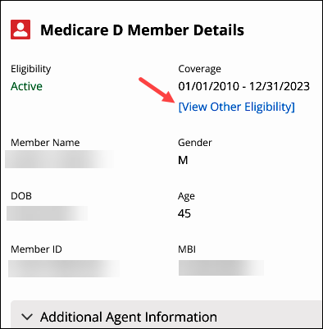

Top of the Document

|  |
| --- |
| **Case Data** |

The Case Data panel contains the following information collected via the Authentication flow:

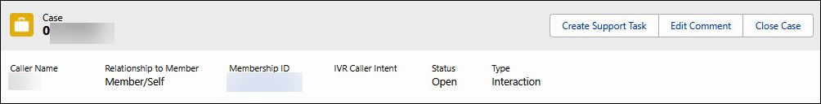

|  |  |
| --- | --- |
| **Section/Field** | **Details** |
| **Case number** | Number assigned dynamically by Compass. |
| **Caller Name** | Name of the caller. |
| **Relationship to member** | Indicates relationship to the member. |
| **Member ID** | Indicates Member’s ID number. |
| **IVR Caller intent** | Indicates the caller intent selected during the IVR Authentication process, if any selected.  **Note:** May be blank if IVR was unable to determine. |
| **Status** | Indicates the status of the case. |
| **Type** | Indicates the type of case (Interaction or Research). |

Top of the Document

|  |
| --- |
| **Medicare D Alerts** |

The Medicare D Alerts panel contains the following:

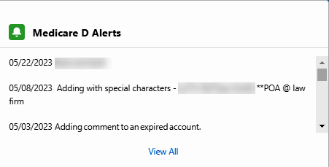

For information on how to view Medicare D Alerts, refer to [Compass MED D - Medicare D Alerts](https://thesource.cvshealth.com/nuxeo/thesource/#!/view?docid=7f5d83d4-94b0-4a59-9b40-3e9ce8b08b62).

|  |  |
| --- | --- |
| **Section/Field** | **Details** |
| **Medicare D Alerts** | The View All hyperlink will display all Medicare D Alerts. |

Top of the Document

|  |
| --- |
| **Medicare D Member Details** |

The Member Details panel contains the following:

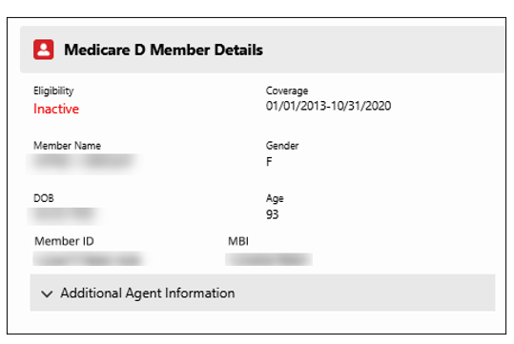

|  |  |
| --- | --- |
| **Section/Field** | **Details** |
| **Eligibility** | * Indicates Active or Inactive. * Medicare related eligibility - displays directly below status, if applicable. |
| **Coverage** | Indicates the effective and expiration dates of the coverage.  **Note:** If additional lines of eligibility are available, a **[View Other Eligibility]** hyperlink will display here: |
| **Member Name** | Indicates member’s name. |
| **DOB** | Indicates the Eligibility date of birth passed for member record. |
| **Age** | Indicates the member’s age. |
| **Member ID** | Indicates member ID found on membership card. |
| **MBI** | Indicates the member’s Medicare Health Insurance Care identification number (red, white and blue Medicare card). |
| **Gender** | Indicates the member’s gender as reported by the plan. |
| **Additional Agent Information** | Indicates what information may be released, based on relationship to the member. |

Top of the Document

|  |
| --- |
| **Medicare D Demographics** |

The Medicare D Demographics panel contains the following:

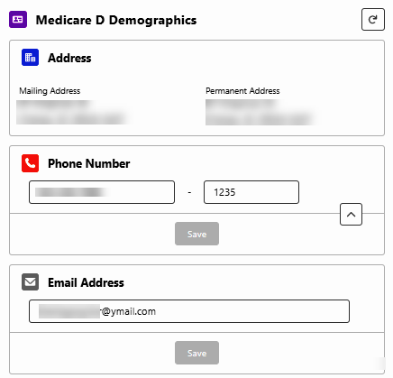

|  |  |
| --- | --- |
| **Section/Field** | **Details** |
| **Mailing Address** | Displays the current mailing address of the member. |
| **Permanent Address** | Displays the permanent address of the member. |
| **Phone Number** | Displays the current phone number of the member. |
| **Email Address** | Displays the current email address of the member. |
| **Refresh button** | Clicking the **Refresh** button in the upper-right corner will update the **Medicare D Demographics** panel to display the latest demographic data. A refresh is needed if a user updates the member’s Med D demographics information in RxEnroll Care, Compass, or PeopleSafe and then navigates back to the Member Snapshot Landing Page. |

Top of the Document

|  |
| --- |
| **Center Panel** |

The Center Panel contains the following tabs:

* Eligibility & Plan
* Premium Billing
* Member Resources

**Eligibility & Plan**

The **Eligibility & Plan** tab contains the following collapsible sections and features:

* Additional Eligibility Details
* Enrollment Details
* Plan Details
* Medicare Interface
* Back to the Top Chevron Arrow

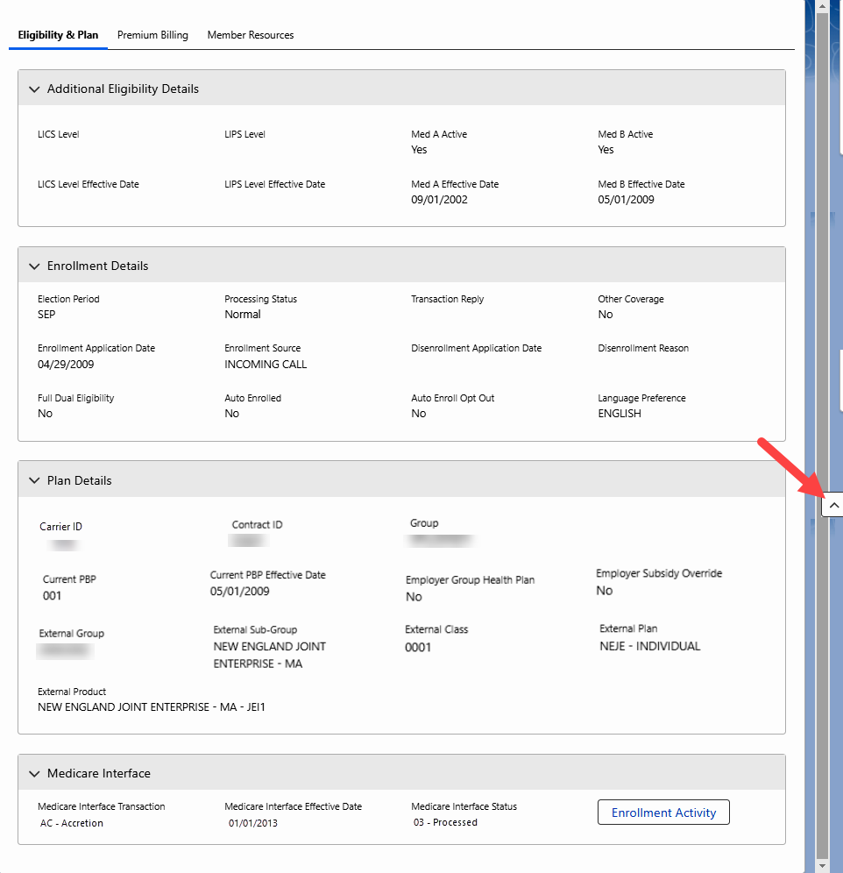

**Additional Eligibility Details**

|  |  |
| --- | --- |
| **Section/Field** | **Details** |
| **LICS Level** | Cost sharing reduction amounts that are applied when a LIS beneficiary fills a script at a pharmacy. |
| **LIPS Level** | Similar to Low Income Subsidy (LIS), indicates the beneficiary is fully subsidized depending on Plan selected. |
| **Med A Active** | Indicates (Yes/No) Med A benefits are active. |
| **Med B Active** | Indicates (Yes/No) Med B benefits are active. |
| **LICS Level Effective Date** | Low Income Cost Sharing (LICS) Indicator effective date. |
| **LIPS Level Effective Date** | Low Income Subsidy (LICS or LIPS) effective date. |
| **Med A Effective Date** | Med A Effective Date. |
| **Med B Effective Date** | Med B Effective Date. |

**Enrollment Details**

|  |  |
| --- | --- |
| **Section/Field** | **Details** |
| **Election Period** | Displays the Election Period. **Example:** All Medicare D beneficiaries have an annual election period from **October 15 through December 7** each year. |
| **Processing Status** | Displays the Processing Status. **Example:** Normal. |
| **Transaction Reply** | Displays the Transaction Reply. **Example:** 011. |
| **Other Coverage** | Displays member’s Other Coverage. If member has other coverage, Compass will show Yes or No. |
| **Enrollment Application Date** | Displays Enrollment Application Date. |
| **Enrollment Source** | Displays the Enrollment Source. **Example:**  Single Transaction Enrollment. |
| **Disenrollment Application Date** | Displays Disenrollment Application Date. |
| **Disenrollment Reason** | Displays Disenrollment Reason. |
| **Full Dual Eligibility** | Displays Yes or No, for Individuals who receive both Medicare and Medicaid benefits. |
| **Auto Enrolled** | Displays Yes or No, if member is Auto Enrolled into coverage. |
| **Auto Enroll Opt Out** | Displays Yes or No, if member has Opted Out of Auto Enrolled coverage option. |
| **Language Preference** | Displays the member’s language preference. **Examples:** English, Spanish, and Other. |

**Plan Details**

|  |  |
| --- | --- |
| **Section/Field** | **Details** |
| **Carrier ID** | Displays the Carrier ID (formerly known as Client Code) and number associated with Member’s plan. |
| **Contract ID** | Contract Identifier (Contract ID)/Plan Benefit Package (PBP) Identifier: A unique number assigned by CMS to designate the type of Medicare Part D Plan. |
| **Group** | An assigned number that identifies a specific account under a plan sponsor (group numbers are subordinate to carrier numbers). |
| **Employer Group Health Plan** | Health insurance offered by an employer, union, or association to its members while they are still working. Employer Group Health Plan coverage is based on current employment. |
| **Employer Subsidy Override** | The PDP sponsor can immediately resubmit the enrollment with the proper employer subsidy override flag. |
| **External Group** | Each employer that purchases a health plan for its employees also has a number. This group number identifies the specific benefits associated you your employer’s plan. Healthcare providers use the group number plus your member ID number to file claims for your care. |
| **External Sub-Group** | Displays the Sub-Group. **Example:** SSI Individual. |
| **External Class** | Displays the External Class number. **Example:** 0002. |
| **External Plan** | Displays the External Plan type. **Example:** SSI – All Regions – 3 Tier. |
| **External Product** | Displays the Product type. **Example:** Silverscript Individual (No SAP): Fulfillment SSIIND01 – SSI1. |
| **Current PBP** | The first three numbers in Plan Namefield is the PBP ID. **Example:** Plan Name = 001 VPLUS, so PBP ID is 001. |
| **Current PBP Effective Date** | Effective Date for Current PBP. |

**Medicare Interface**

|  |  |
| --- | --- |
| **Section/Field** | **Details** |
| **Medicare Interface Transaction** | Displays the Medicare Interface Transaction type. **Example:**  AC- Accretion. |
| **Medicare Interface Effective Date** | Displays the Effective Date. |
| **Medicare Interface Status** | Displays the Medicare Interface Status. **Example:** 03-Processed. |
| **Enrollment Activity (Button)** | Button will display the Enrollment Activity. |

**Back to the Top Chevron Arrow**

|  |  |
| --- | --- |
| **Section/Field** | **Details** |
| **Eligibility tab,**  **Mail Order Profile tab, and**  **Mail Order Payments tab** | The back to top chevron arrow  (to the right and left of the panel) will allow agent to quickly navigate back to the top of the page without manually scrolling. |

**Premium Billing**

The **Premium Billing** tab contains the following collapsible sections and features:

* One-Time Payment & Automatic Payment
* Balance Details & Payment Plan
* Premium Details
* Billing History
* Payment & Adjustments
* Rate Data
* Billing Cycle & Payment Method

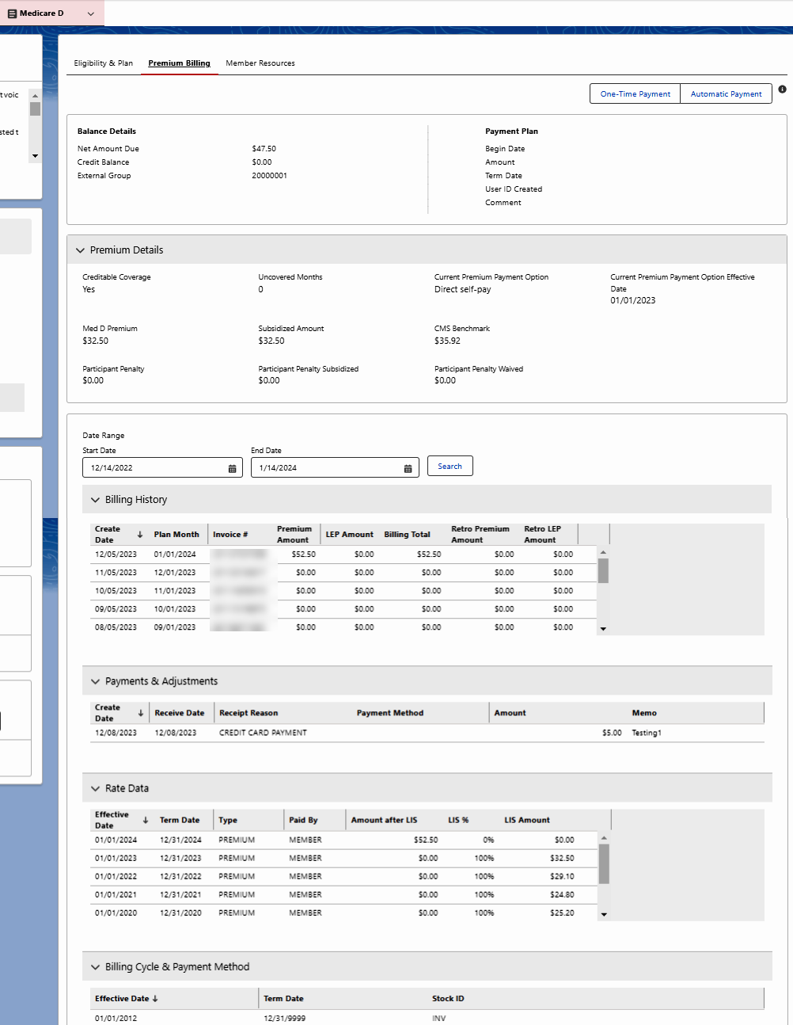

**One-Time Payment & Automatic Payment**

|  |  |
| --- | --- |
| **Buttons** | **Details** |
|  | **One-Time Payment** button is used for One-time payments. When clicked, the CCR is automatically redirected to the Premium Payments Single-Sign-On (SSO) system. |
|  | **Automatic Payment** button is used for automatic payments. When clicked, the PREMIUM BILLING SPECIALIZED CARE TEAM is automatically redirected to the Credit Card Single-Sign-On (SSO) system. |

**Balance Details & Payment Plan**

|  |  |
| --- | --- |
| **Section/Field** | **Details** |
| **Net Amount Due** | Displays the net amount due dollar amount. |
| **Credit Balance** | Displays the credit balance available. |
| **External Group** | Displays the External group number. |
| **Payment Plan: Begin Date** | Displays the payment plan begin (start) date. |
| **Payment Plan: Amount** | Displays the amount due on the payment plan. |
| **Payment Plan: Term Date** | Displays payment plan termination date. |
| **Payment Plan: User ID Created** | Displays unique User ID. |
| **Payment Plan: Comment** | Displays any payment plan comments. |

**Premium Details**

|  |  |
| --- | --- |
| **Section/Field** | **Details** |
| **Creditable Coverage** | Indicates (Yes/No) for Creditable Coverage. |
| **Uncovered Months** | Indicates the number of months the Member was not covered. |
| **Current Premium Payment Option** | Displays the member’s current payment option. **Example:** Direct self-pay. |
| **Current Premium Payment Option Effective Date** | Displays the effective date for the member’s current premium payment option. (MM/DD/YYYY) |
| **Med D Premium** | Displays the dollar amount the member pays for the Premium. |
| **Subsidized Amount** | Displays a reduced price for the premium, if the government has paid for part/all of the cost. |
| **CMS Benchmark** | Displays an established price (target price) for services. |
| **Participant Penalty** | Displays the member’s penalty amount if any. |
| **Participant Penalty Subsidized** | Displays the subsidized (reduced) penalty amount. |
| **Participant Penalty Waived** | Displays the waived penalty amount. |

**Billing History**

|  |  |
| --- | --- |
| **Section/Field** | **Details** |
| **Create Date** | Displays the date the bill was created. (MM/DD/YYYY) |
| **Plan Month** | Displays the month the member was billing for the plan. |
| **Invoice # (12 digits)** | Displays the invoice number for a specific bill. |
| **Premium Amount** | Displays the amount the member was billed for the premium. |
| **LEP Amount** | Displays an amount (penalty) that may be permanently added to a member’s monthly premium. |
| **Billing Total** | Displays the billing total. |
| **Retro Premium Amount** | Displays a payment amount made by a policyholder to an insurance company that is not based on a fixed amount but, rather, on the claims made during a policy period. |
| **Retro LEP Amount** | Displays a retroactive amount that will be added to a member’s monthly premium. |

**Payments & Adjustments**

|  |  |
| --- | --- |
| **Section/Field** | **Details** |
| **Create Date** | Displays the payment/adjustment date. (MM/DD/YYYY)  **Note:** Click the arrow next to the column header to sort results by the date (Newest to Oldest). |
| **Receive Date** | Displays the date the payment/adjustment was received. (MM/DD/YYYY) |
| **Receipt Reason** | Displays a description of the reason for payment/adjustment. |
| **Payment Method** | Displays the type of payment method (**Example:** (Visa/Mastercard/Check). |
| **Amount** | Displays the payment/adjustment dollar amount. |
| **Memo** | Displays a written message. |

**Rate Data**

|  |  |
| --- | --- |
| **Section/Field** | **Details** |
| **Effective Date** | Displays the date effective date.  **Note:** Click the arrow next to the column header to sort results by the date (Newest to Oldest). |
| **Term Date** | Displays the termination date. |
| **Type** | Displays the Type. **Example:**  Premium. |
| **Paid By** | Displays who made the payment. **Example:** Member. |
| **Amount after LIS** | Displays the amount after Low Income Subsidy has applied. |
| **LIS%** | Displays the percentage Low Income Subsidy will cover. |
| **LIS Amount** | Displays the Low Income Subsidy dollar amount. |

**Billing Cycle & Payment Method**

|  |  |
| --- | --- |
| **Section/Field** | **Details** |
| **Effective Date** | Displays the date effective date. |
| **Term Date** | Displays the termination date. |
| **Stock ID** | Displays (**Code** – Description). **Example:**  **EFT/RCD** = Auto payments; **INV** = Direct invoice; **RRB** = Railroad Board; **SSA** = Social Security |

**Member Resources**

The **Member Resources** tab contains the following collapsible sections and features:

* Member Resource History
* New Member Resource Order
* No Records Found

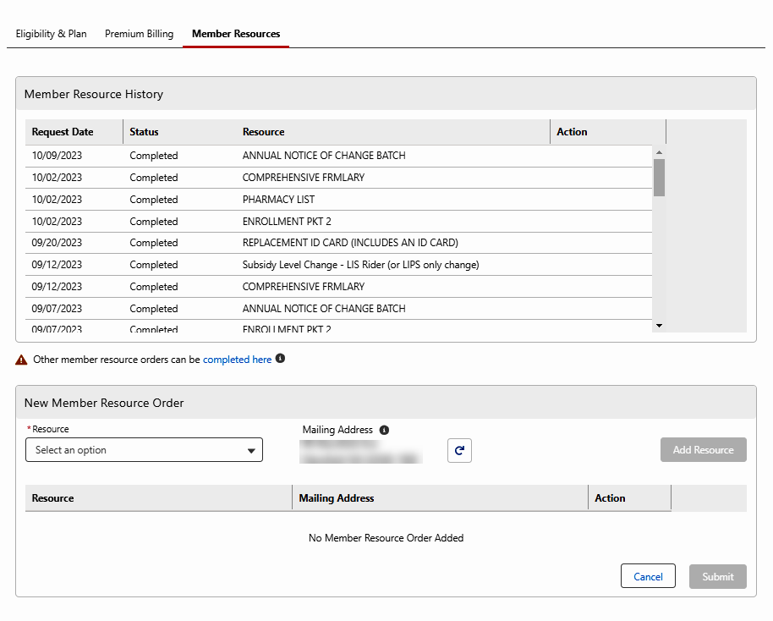

**Member Resource History**

|  |  |
| --- | --- |
| **Section/Field** | **Details** |
| **Request Date** | Displays the date that the resource was requested in (MM/DD/YYYY) format.  **Note:** Click on the arrow next to the labeled column header to sort results by date (Newest to Oldest). |
| **Status** | Displays the current state of the resource request. **Example:** Pending, In Process, or Completed. |
| **Resource Description** | Displays a title or brief description for what resource is being requested.  **Note:** Click on the arrow next to the labeled column header to sort results by date (Newest to Oldest). |
| **Action** | Displays the option to **Cancel** Order if available based on an in-progress or initiated order. |

**New Member Resource Order**

|  |  |
| --- | --- |
| **Section/Field** | **Details** |
| **Resource Dropdown** | * Annual Notice of Change (ANOC) * Coordination of Benefits Survey Letter * Disenrollment Form * Evidence of Coverage (EOC) replacement * LIS Rider * RMAA letter ID S026 * Plan start ratings * Replacement ID card (includes an ID card) * Summary of Benefits * Welcome Kit   **Note:**  Options are dynamic and may vary by client. |
| **Resource Description** | Displays a title or brief description for what resource is being placed in the order. |
| **Mailing Address** | Displays the selected mailing address of the member. |
| **Action** | Displays the option to **Remove** the resource from the order. |

**No Records Found**

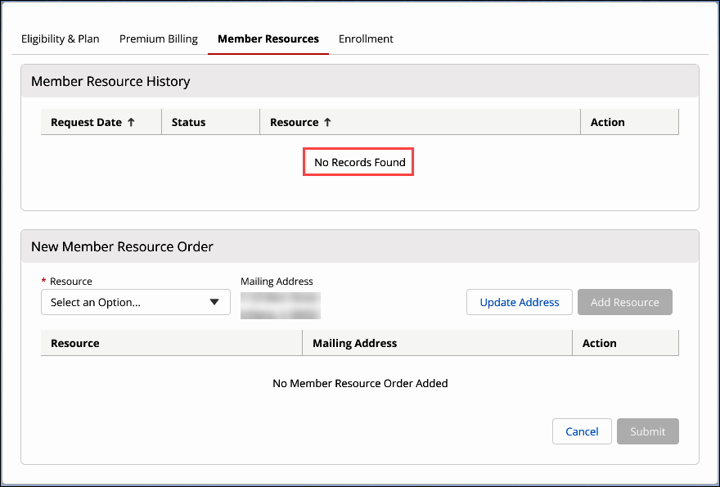

Top of the Document

|  |
| --- |
| **Medicare D Quick Actions** |

This section contains the following **quick actions** that will open a new tab for access to additional member plan details.

**Note:** Some Quick Actions hyperlinks are Client Specific and will not display for some members.

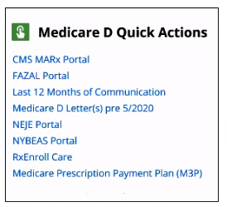

|  |  |
| --- | --- |
| **Section/Field** | **Details** |
| **CMS Marx Portal** | Used to access the CMS.gov Enterprise Portal page. CMS has established an Identity Management (IDM) secure website providing a means to apply for, obtain approval, and receive a single User ID to access the Medicare Advantage and Part D Inquiry System Online Operations (MARX) application. Hyperlink used to access the CMS.gov Enterprise Portal page. |
| **FAZAL Portal** | Used to access the FAZAL application when handling pre-enrollment and post enrollment.  **Example:** When a prospective beneficiary inquires about the status of their submitted enrollment application. |
| **Last 12 Months of Communication** | Used to access communications sent to the member in the last 12 months. |
| **Medicare D Letter(s) pre 5/2020** | Used to access available letters for the member in the RR Donnelly system. |
| **NEJE Portal** | Used to access the Blue MedicareRx (NEJE) Enrollment application. |
| **NYBEAS Portal** | NYBEAS Portal is the benefit system for NYSHIP. This system allows us to view, if the member has active coverage, and when there were any changes to their coverage, covered dependents, and if member is Medicare eligible. |
| **RxEnroll Care** | Used to Enroll the Med D Members into RxEnroll Care. |
| **Medicare Prescription Payment Plan (M3P)** | Used to access the Medicare Prescription Payment Plan (M3P) tab.  **Note:** The Medicare Prescription Payment Plan program is abbreviated as MPPP by CMS and may be known by members as MPPP. At this time, the program is referred to as M3P in the Compass system. |

Top of the Document

|  |
| --- |
| **Related Documents** |

**Parent Document:**  [CALL-0049 Customer Care Internal and External Call Handling](https://policy.corp.cvscaremark.com/pnp/faces/DocRenderer?documentId=CALL-0049)

Top of the Document

Not to Be Reproduced or Disclosed to Others without Prior Written Approval

**ELECTRONIC DATA = OFFICIAL VERSION / PAPER COPY = INFORMATIONAL ONLY**